**Conceptual Design & Logical Design**

1. **Conceptual Design:**
2. **Handling Entities:**

* Museum.
* Account.
* Displayed Object.
* Target.
* Guest Request

1. 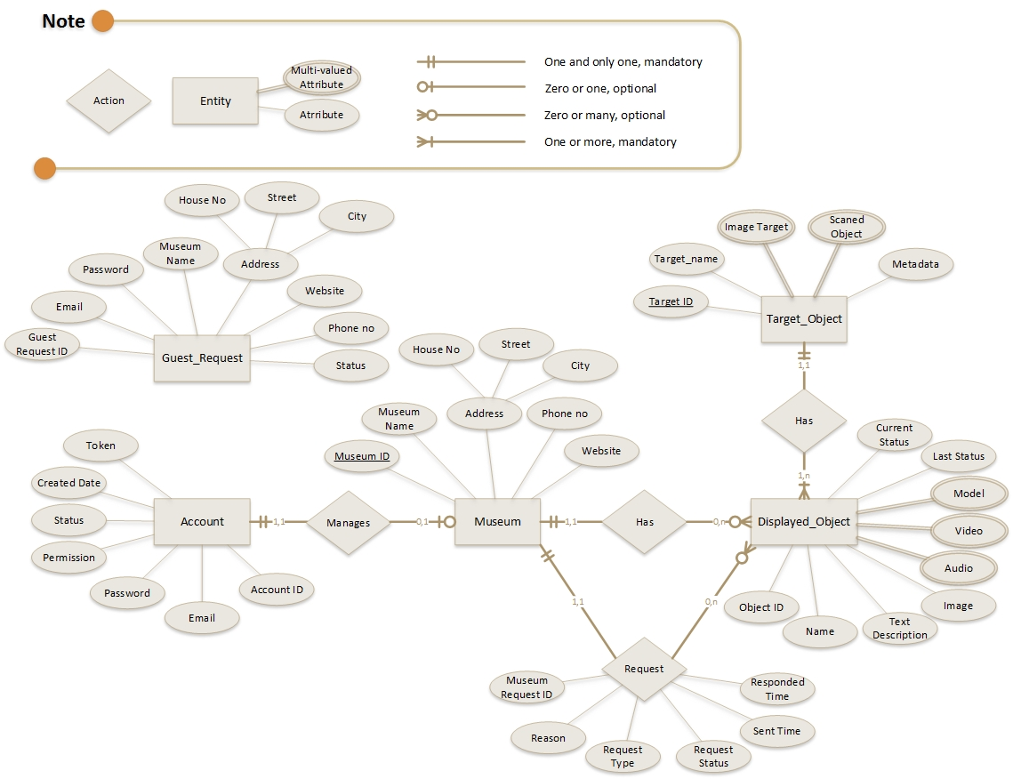**ER Diagram :**
2. **Entity Relationship**:

Data Dictionary showing a description of relationship:

|  |  |  |  |  |
| --- | --- | --- | --- | --- |
| Entity name | Multiplicity | Relationship | Multiplicity | Entity name |
| Account | 1..1 | Manages | 0..1 | Museum |
| Museum | 1..1 | Has | 0..* | Display Object |
| Museum | 1..1 | Request about | 0..* | Display Object |
| Display Object | 1..n | Represents | 1..1 | Target |

1. **Logical Design:**
2. **Translate To Table:**

Account (**account_id**, email, password, permission, status, created_time,token).

Museum (**museum_id**, account_id, museum_name, house_no, street, city, phone_no, website).

Displayed_object (**do_id**, target_id , museum_id, name, text_description, image, audio, video, model, current_status, last_status).

Target (target_id, target_name, target_image, scaned_object, metadata).

Guest_Request (**g_request_id**, email, password, museum_name, house_no, street, city, phone_no, website, status).

Member_Request (**m_request_id**, museum_id, dob_id, reason, request_type, request_status, sent_time, responded_time).

1. **Data Dictionary:**

Data Dictionary showing a description of attribute:

|  |  |  |  |  |  |  |  |
| --- | --- | --- | --- | --- | --- | --- | --- |
| Table name | P/F | Attribute | Description | Data Type | Length | Null | Multi-valued |
| Account | **P** | **account_id**  email  password  permission  status  created_time  token | Uniquely identify an account.  Email of account.  Password of account.  The role of account.  *(0 = Admin; 1=Museum)*  Current status of an account.  *(0 = De-active ; 1 = Active)*  The time when account was created.  The token | Int  Nvarchar  Nvarchar  Int  DateTime  Nvarchar | 50  16 | No  No  No  No  No  No | No  No  No  No  No  No |
| Museum | **P**  **F** | **museum_id**  account_id  museum_name  address  house_no  street  city  phone_no  website | Uniquely identify a museum.  ID account that manages museum.  Public name of museum.  Address of museum.  Phone number of museum.  Website of museum. | Int  Int  Nvarchar  Nvarchar  Nvarchar  Nvarchar  Nvarchar  Nvarchar | 150  30  30  30  20  50 | No  No  No  No  No  No  No | No  No  No  No  No  No  No |
| Displayed_object | **P**  **F**  **F** | **do_id**  museum_id  target_id  name  text_description  image  audio  video  model  current_status  last_status | Uniquely identify an object.  Uniquely identify a museum.  Uniquely identify an object’s target.  Name of an object that is displayed.  Description of object of museum  Link of object image  Link to information of object of museum in audio format.  Link to information of object of museum in video format.  Link to information of object of museum in 3D model format.  Current status of object.  *(-1=Deleted, 0=Pending, 1=Available, 2=Active.)*  Last status of object. | Int  Int  Int  Nvarchar  Nvarchar  Nvarchar  Nvarchar  Nvarchar  Nvarchar  int  int | 150 | No  No  No  No  Yes  Yes  Yes  Yes  Yes  No  Yes | No  No  No  No  No  No  Yes  Yes  Yes  No  No |
| Target_Object | **P** | **target_id**  target_name  target_image  scaned_object  metadata | Uniquely identify an object’s target.  Name of target.  Link to image target of object that can be used as target.  Link to object scan file of object that can be used as target.  Link to metadata of target. | Int  Nvarchar  Nvarchar  Nvarchar  Nvarchar | 30 | No  No  Yes  Yes  Yes | No  No  Yes  Yes  Yes |
| Member_Request | **P**  **F** | m_request_id  museum_id content  request_type  do_id  reason  request_status  sent_time  responded_time | Uniquely identify a member request.  Uniquely identify an account.  Content of request from member.  Type of request  *(0=Delete request;1=Change request).*  Id of display-object want to send request  Reason why want to make the request.  Current status of request  *(0 = Pending, 1=Accepted,2=Deny)*  Time request was sent  Time request is approved by admin | Int  Int  int  Int  Nvarchar  int  DateTime  DateTime |  | No  No  No  No  Yes  No  No  Yes | No  No  No  No  No  No  No  No |
| Guest_Request | **P** | **g_request_id**  email  password  museum_name  address  house_no  street  city  phone_no  website  status | Uniquely identify a guest request.  Email of guest museum  Password of account use to login.  Public name of museum.  Address of museum.  Phone number of museum.  Website of museum.  Current status of request  *(0 = Pending, 1=Accepted,2=Deny)* | Int  Nvarchar  Nvarchar  Nvarchar  Nvarchar  Nvarchar  Nvarchar  Nvarchar  Nvarchar  int | 50  16  150  30  30  30  20  50 | No  No  No  No  No  No  No  No  No  No | No  No  No  No  No  No  No  No  No  No |

1. 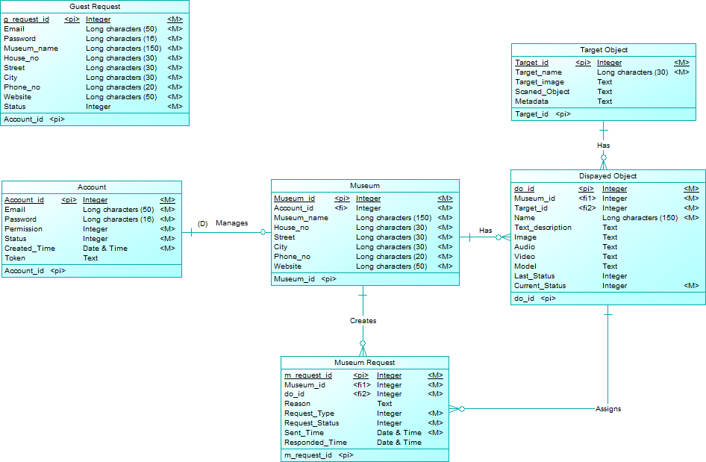**Table Diagram**